How to Create a User Account on the Stoke Professional Portal
The Professional Portal will allow you to submit a referral to the Stoke SEN team requesting a SEN Assessment for a child, and also enables you to attach the required documents electronically for submittal to the Stoke SEN Team.
The URL of the portal is below, copy and paste this into an internet browser to get to the log in and registration screen. Please add this to your internet favourites for future use.
https://www.admissions.stoke.gov.uk/ProfessionalPortal_LIVE/Account/Login
Firstly, you will need to register for a portal account by clicking the word Register highlighted below.
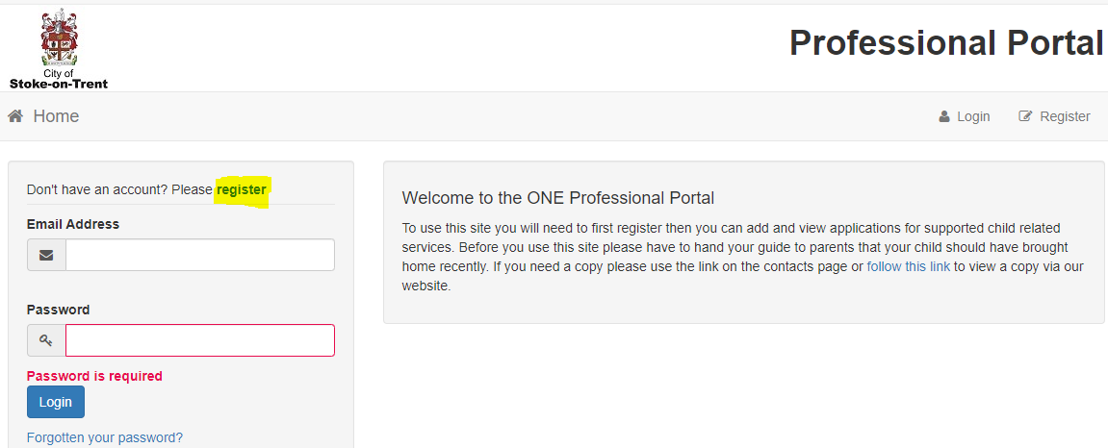
We will need your email address, we suggest using your works email address, as when each time you log on, you will receive a verification code that is needed to complete the log in process, and also, if you are sent a portal message, you will automatically receive an email advising you there is a portal message awaiting to be read. So, using an email address that you have constant access to is advised.
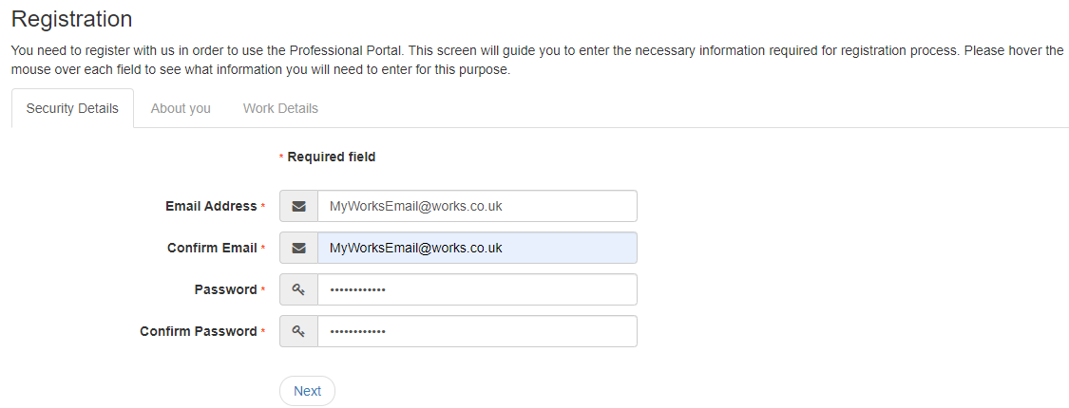
Note, these are the rules for creating a valid password’
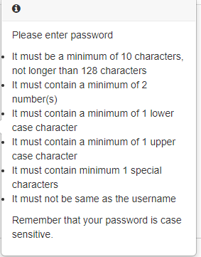

Then fill in your personal details and then click Next.
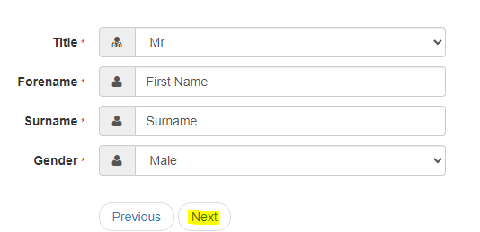

Now fill In your work details;
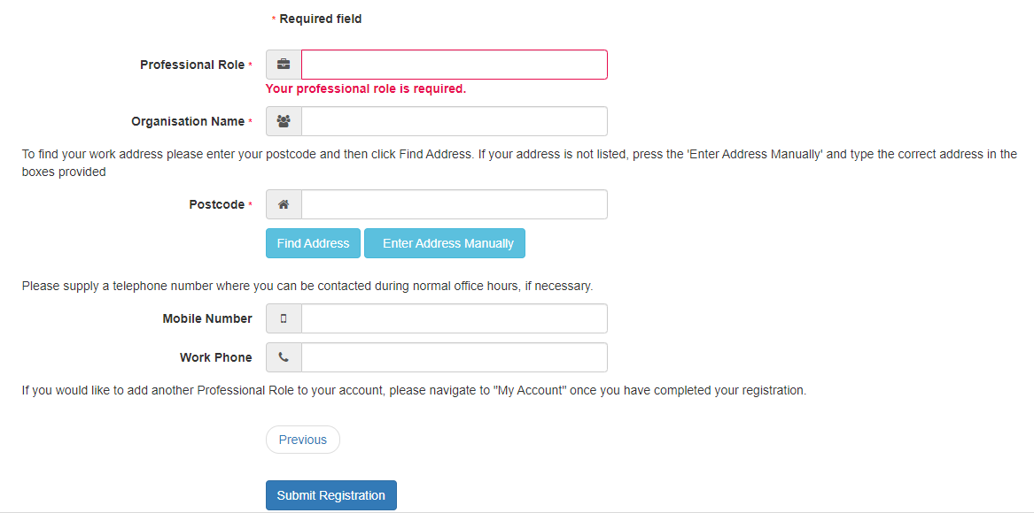
In the professional role, if you are a SENCO, start typing SE and the system will automatically present you with the SENCO option to select.
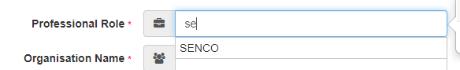

For the postcode, type in your postcode and then click find address and the system will present you with the list of addresses in the system for you to select the relevant one.
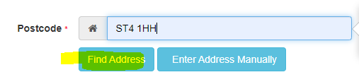
Once you have completed all of the details, then click submit registration.
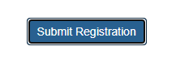

You will then see this message on screen, advising that you have been sent an email with a verification link which you must click to complete registration.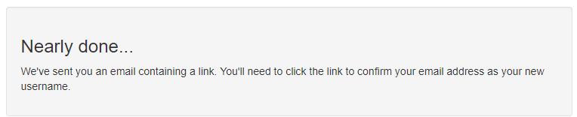
This is the activation link in the email you need to click.
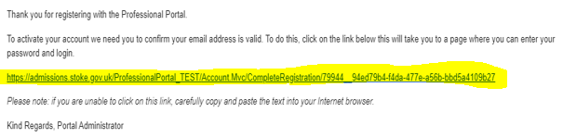
When you have clicked the emailed link, your account is then set up and you can then log in using the email address you entered and password you set.
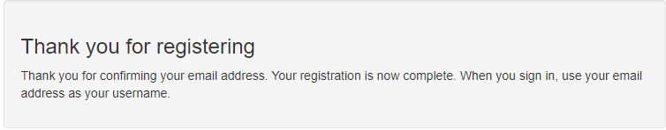
Your Account is now set up, refer to the document on how to log a request for assessment for a child.
Please email onesupport@stoke.gov.uk to advise you have set up your portal account from the email address you have registered with the portal, we can then add you to the email group so we can advise you if the portal is down for maintenance.

