How to Log a Request for a Child to be considered for a SEN Assessment using the Stoke Professional Portal.

Contents
1. Initial Dashboard after Log In 2
2. How to Enable Two-Step Verification so you can submit requests 3
3. Logging in Using Two Step Verification 4
4. Portal Time Out 6
5. How to Submit a Request 6
6. Adding a Child to Make a Request About 7
7. Starting the Request form 8
8. Filling in the Assessment Request Form 10
9. Question Types 10
Mandatory Questions 10
Text Questions 10
Yes/No Questions 10
Date Questions 11
List Question 11
Document Attachment Question 12
Multiple Answer Questions 13
10. Moving to the Next Page in an Assessment Request 14
11. Form Completion and Summary 14
12. Agreements 15
13. What happens to your Request 16
14. How to deal with a Request for Additional Information 16
15. How to Print off a Submitted Request Form 20

- Initial Dashboard after Log In.
The web address for the Stoke Professional Portal is;
https://www.admissions.stoke.gov.uk/ProfessionalPortal_LIVE/Account/Login
When you log In, you will see the home page as shown below;
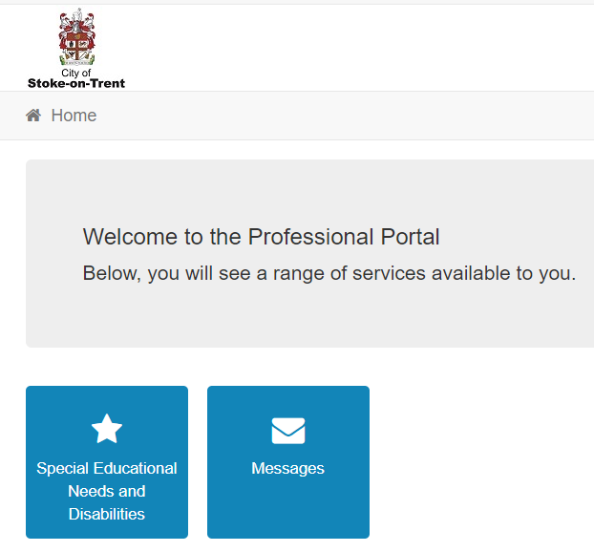
Any unread portal messages will appear as a number on the message’s icon, if there are no numbers showing, then there are no unread messages waiting to be read.
To make a request for the Stoke SEN team to consider a child for a SEN Assessment, click on the icon entitled Special Educational Needs and Disabilities. Please note, that as we further develop the portal, additional forms may appear as Icons in this section.

How to Enable Two-Step Verification so you can submit requests
Click on the icon entitled Special Educational Needs and Disabilities.
The first time you do this, you will see this message, it will enforce you to switch on two step verification when you log in to increase the security of user profile, as you will be adding in personal details of children, so this extra level of security is enforced.
To enable Two Step Verification, click on the link which is highlighted below;
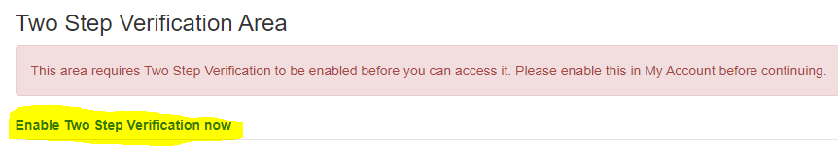
You will then see this message, in the preferred method box, change this value from No Two Step Verification to Email and then click save.
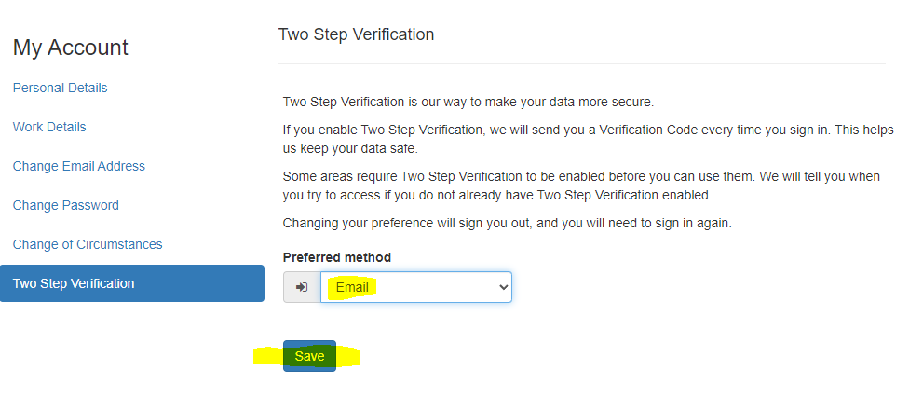

This has now enabled two step verification on your account and will automatically log you out of the portal, so you can then re-log back in using the two-step verification process.

Logging in Using Two Step Verification
Log into the Professional Portal using your chosen email address and password.
You will then get a verification code box as below;
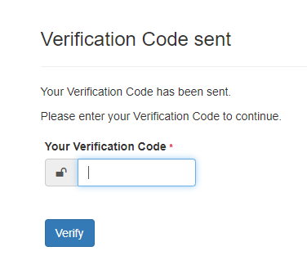

You need to go to your chosen email address, and you should see a new email that looks something like this.

If you open the email, it looks like this, it is just the first part of the first sentence you are interested in, copy and paste the verification code to complete your log in.
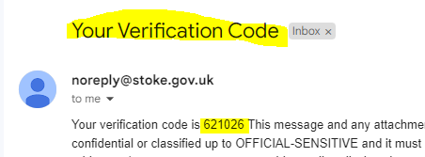

You will then be back to the home screen
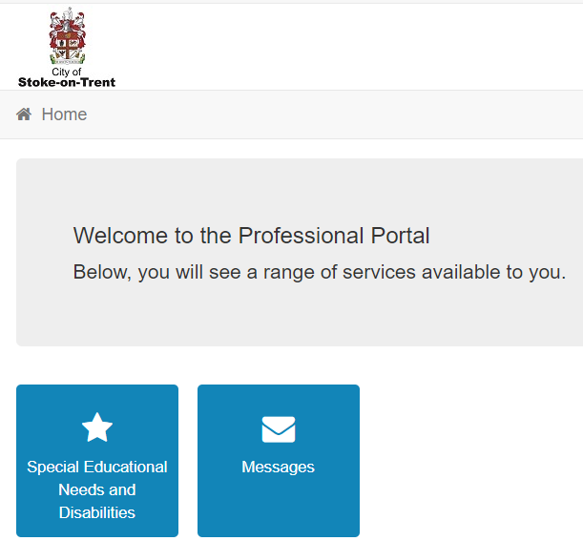

Portal Time Out

Please note that there if the portal is open and you head off to do some other work, it will automatically log you out after 10 minutes inactivity if you don’t return to that page within 10 minutes and any work on that current page will be lost as there is no autosave on the product.
The recommendation is that you complete a page with as much as you can and then click save and continue onto the next page, this ensures your previous page’s work is saved if the system times out on you.
You can always return to that page at a later date if you don’t have all of the information to hand.

How to Submit a Request
From the home screen, click on the Special Educational Needs and Disabilities Icon.

The first time you click on this icon you will see the following message and have the option to add a child who you are making a request about. If you have previously submitted any requests, the children will be listed for you to see.
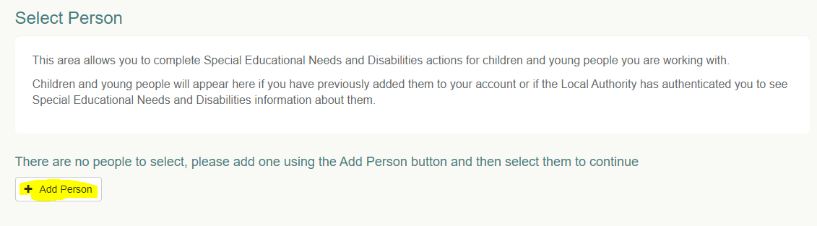

Adding a Child to Make a Request About
Fill in the child’s details including their current school which can be selected from the list.
Note, the postcode is the postcode of the Child’s home address, not their current school address.
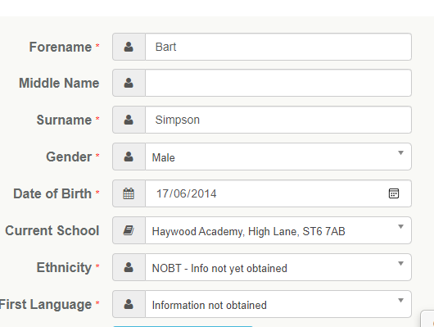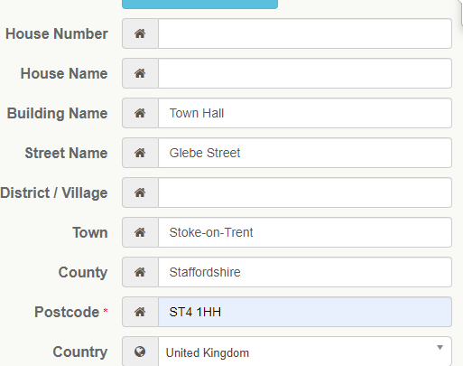
With regard to the address, enter a postcode and then click Find Address and it will list all the potential addresses, the list should contain all addresses in the Staffordshire area, however if the address isn’t in the list, click the Enter Address Manually button and it will allow you to enter the address.
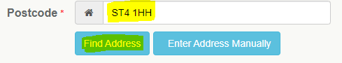
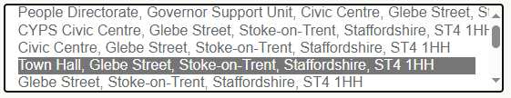
Once you have completed all the information fields, click the Add Child button and the system will then present the Request an Assessment Screen.

Starting the Request form
After adding a new child or selecting an existing child from your list, you will then see this screen where you can submit a request for a Statutory Assessment.
Click the start button to start the request form.

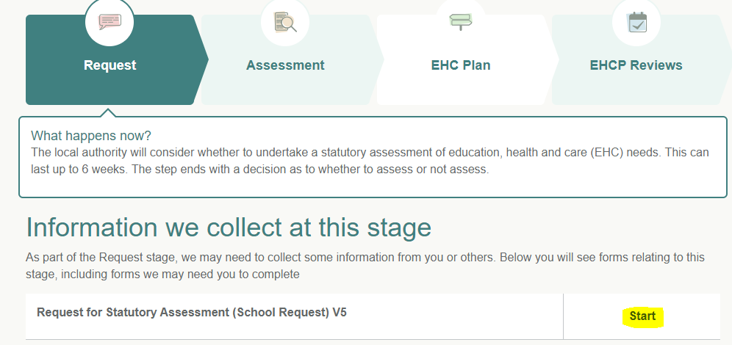

This is just a confirmation screen, click the start button again please.
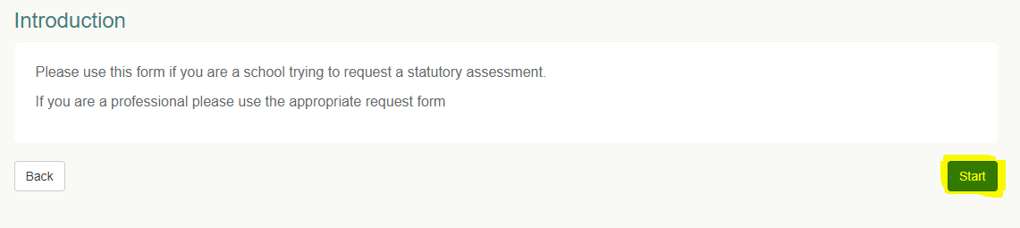
You will be asked to confirm your work role, most of the time you will only have one entry in here, you would only have more than one, if you changed roles and you add a new entry for this role.
Select the role and click the Start button.
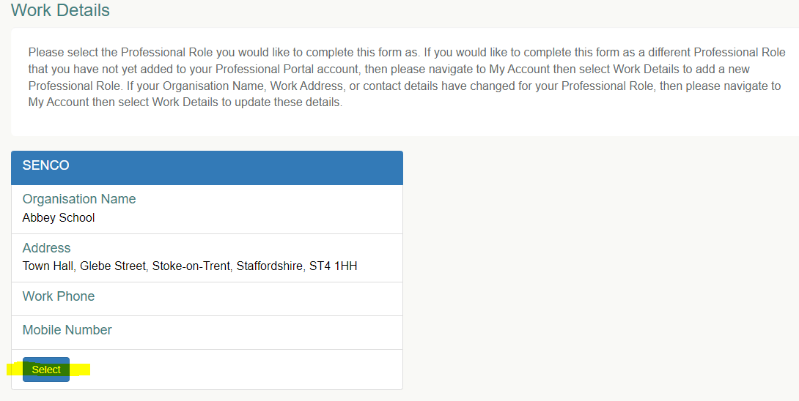

Filling in the Assessment Request Form
At the top of the screen, this will display the number of steps to complete the form and the step highlighted in green, is the current step you are on;
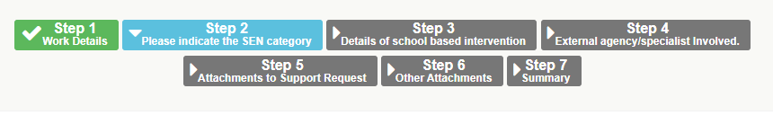

Question Types

Mandatory Questions
Any question with a red Asterix next to the question, indicates this is a mandatory question and you will have to fill an answer for all mandatory questions, otherwise the system will prevent you moving onto the next page of the request form. The reason these are mandatory is that it has been deemed that Stoke require this information to process the request.
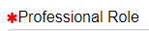

Text Questions
Text box questions require you to fill in the answer and there are 30000 characters available to be used.
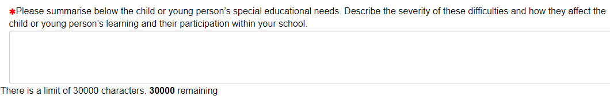

Yes/No Questions

There are a number of Yes/No questions regarding the potential issues a child may encounter, the default setting is No, and to answer Yes, click to the left of the word No and this will change the answer to Yes.
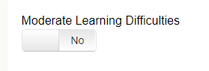

Date Questions
With a date question, you can either type in the date or click on the calendar icon and select from the calendar.
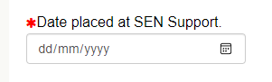

List Question
On List Question, there is already a pre-populated list to select from;
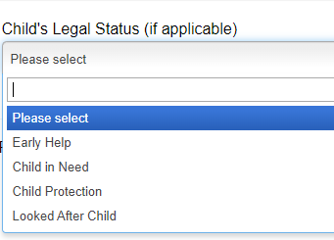

Document Attachment Question
There are a large number of document attachment questions, those with the red Asterix are mandatory, which means you will need to update the relevant document to allow you to complete the Assessment Request form. The mandatory questions provide the minimum documents Stoke Council require to consider the assessment request.
The type of files and the size of 10MB are clearly included in the description but are;
bmp, doc, docx, jpeg, jpg, pdf, png
If you have a spreadsheet to include, I suggest highlighting the relevant fields and then copying and pasting these into a word document, as this is an unloadable type and Excel files are not.
Firstly, you will need to click on the Choose File option, so you can select the relevant file to upload.
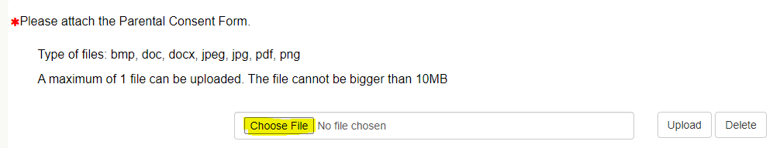

This will open the Windows Explorer window where you can navigate and locate the relevant file to upload and then click the Open button;

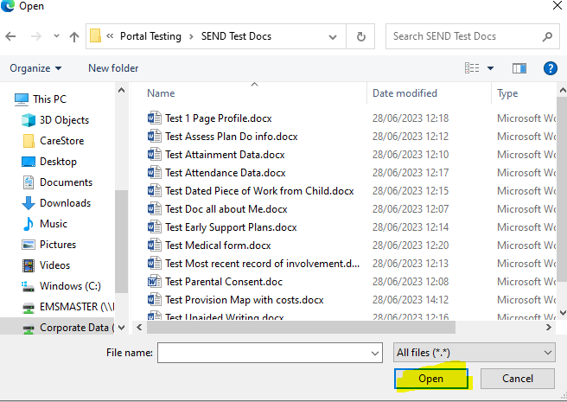

The filename is displayed, you now need to click the Upload button, to attach the selected file to the Assessment Request form;
Once Uploaded, you will see the file name and file size displayed. There is a delete button if you have uploaded the incorrect file;
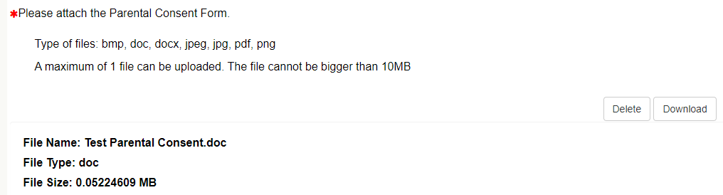

Multiple Answer Questions

There are some questions where you may want to add more than one answer. An example of this is the external agencies involved question, you fill in the details for the first agency and then click the add more button and this will allow you to then answer the same questions again, but for a different agency. You can add more, multiple times if required.

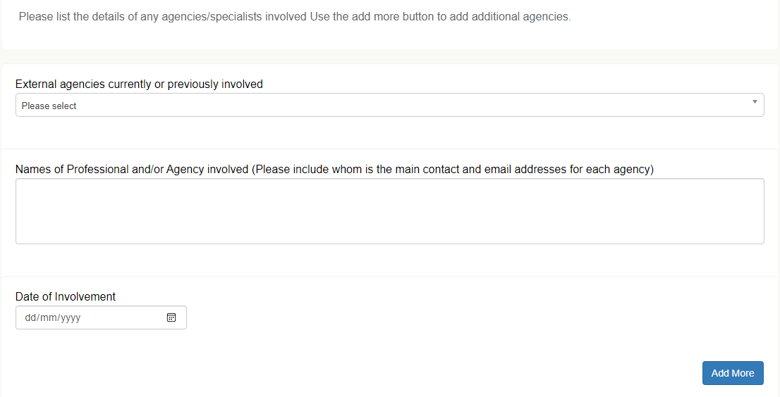

Moving to the Next Page in an Assessment Request
When you have completed all of the relevant questions on a page, click the Save & Continue Button to move to the next page;

If, however, you have not answered a mandatory question, you will get this error message;
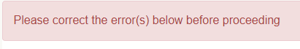
Locate the mandatory question you have not answered, one answered, you should then be able to click the Save & Continue Button and then progress to the next page in the assessment.

Form Completion and Summary
Once you have completed each page of the assessment, a summary page is displayed showing all of the answers, if you wish to change anything, click the back button and you will return to the assessment.

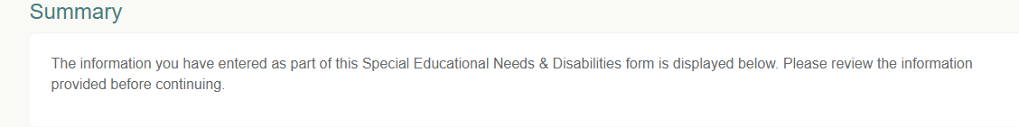

Agreements
If you are happy with all of the answers given and the documents you have attached to support the Assessment Request, there are Two statements you need to read carefully and agree to if acceptable;
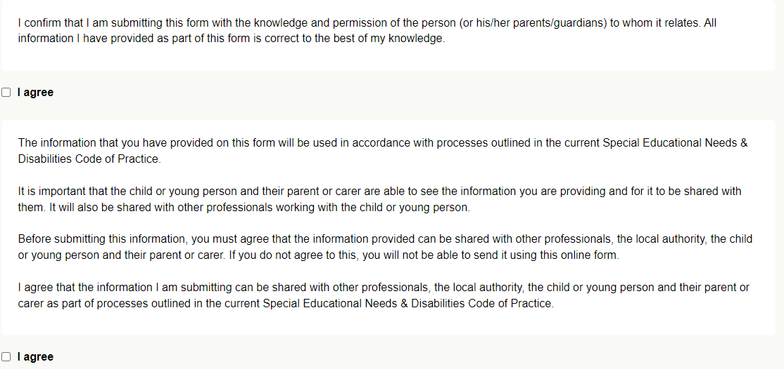
Once you have agreed to these two statements, you then click the submit button and this request will be electronically sent to the Stoke SEND team inbox.
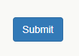

What happens to your Request
The submitted request will be check by the SEN team to see if they have all of the information they require and if so, then they will make the decision on whether to assess or not. You will receive a message through the portal to advise whether the Request for Assessment has been successful or not,

How to deal with a Request for Additional Information
If the SEN Team require additional information to consider the assessment request, they will send you the request via the SEND Portal. You will also receive and email to advise that you have received a portal message and you need to log into the portal to read the actual message.
So, when you log into the Portal, there is one unread message showing in the Message Icon. Click on the message icon, to open the message page.

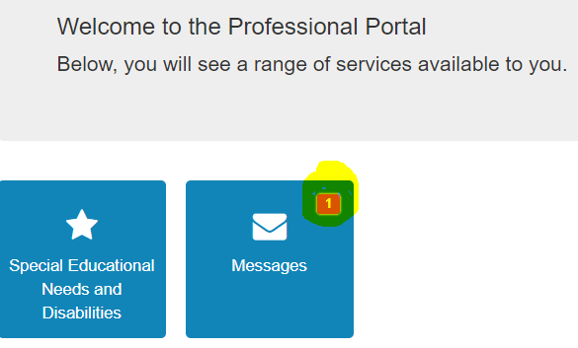
When we open the message, we can see that they are requesting more information than what was originally sent. So navigate back to the home page;

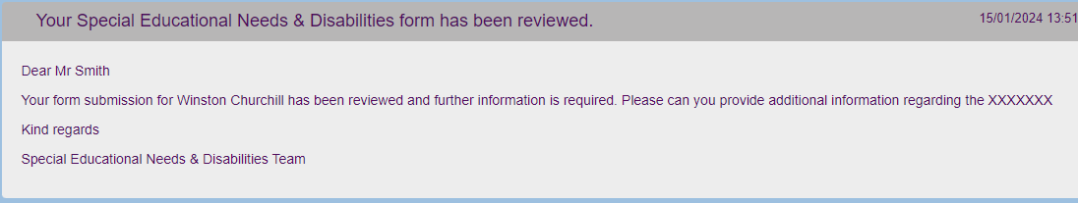
And then click on the Icon below, where all the assessment details are stored.

Select the child from the list of children you are working with, by clicking on their name;
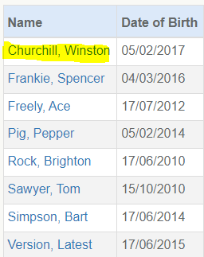

When we open the assessment page for Winston Churchill, we now see two options, the, top option is the original request we made and we need to click the edit button so we can edit and add in the additional information that has been requested.
In this case, don’t click the start button, as this will start a brand new request, we just need to edit the one we had previously sent as all of the answers we previously supplied are all there in the version we are going to edit.

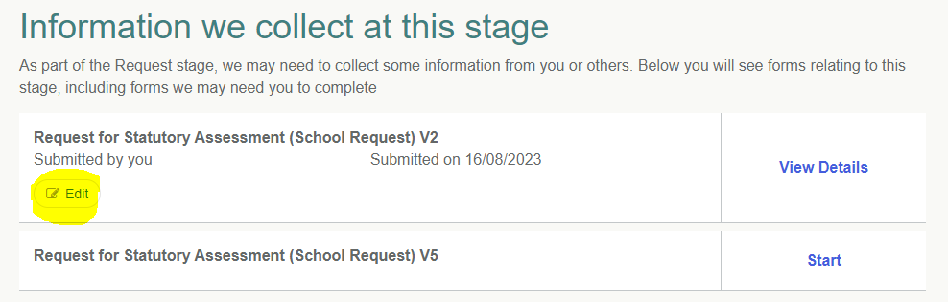

When you click the edit button, you will see this message which just confirms you are editing the form and that you need to work all the way through the form to get to the final submit button, to re-submit the Assessment Request.

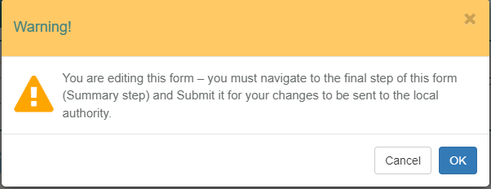

You will need to work through each page and when you are happy with that page, click the continue button. Make sure that you include the additional information that the Stoke SEN team have requested.
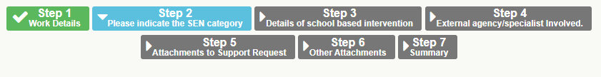
Once you have worked through each page and amended where necessary and clicked the submit button to send the revised version back to Stoke, you will now see that there are 3 entries in our list now, the revised form we have just amended is top of the list as it is the most recent version of the form. If we were requested to include even more additional information, then this is the version we would need to edit next time round, as it is the most recent version.
Second is the original form that was sent and which has now been superseded.
The third item is the new form for a new application;

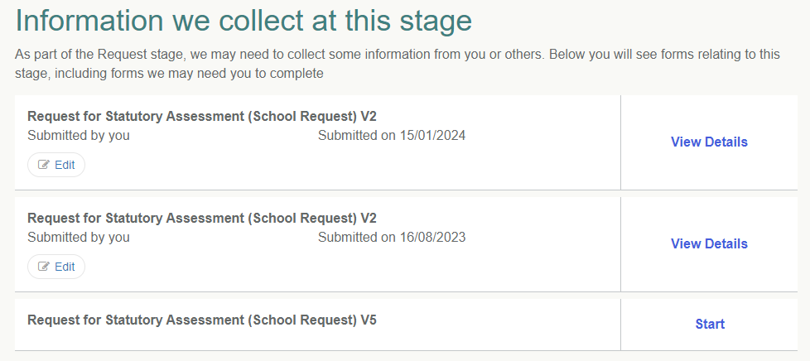

How to Print off a Submitted Request Form
Having filled in and submitted a Request for Assessment form, you may want to print off this form to out into a Child’s Paper file.
From the Home page, click on the Special Educational Needs and Disabilities icon;
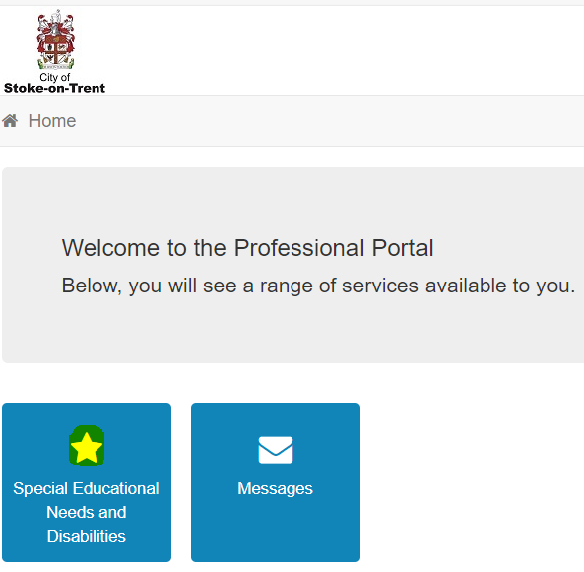

You will then see a list of the children you have submitted request form’s for, click on the Child whose request form you want to print off. It will then display the child’s details, click the continue button to get to the assessment list page;
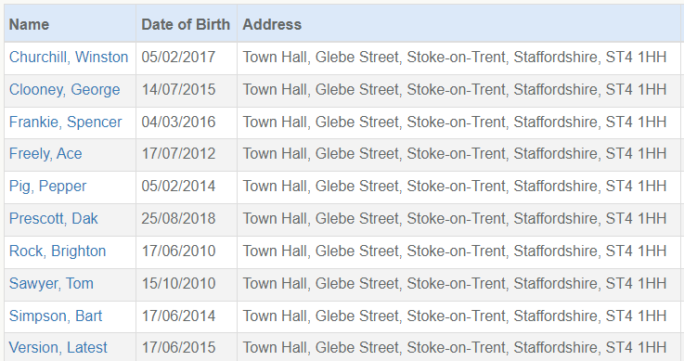
Click the View Details to open the Request form;

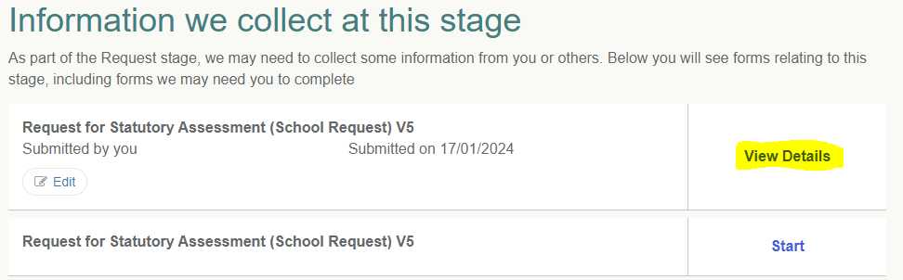

If you are using Microsoft Edge, click on the three dots icon in the toolbar at the top of the screen and in the top right-hand corner;
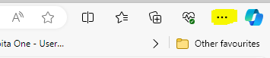
You will then see a pop-up window, select the Print option and then you can print the assessment off.
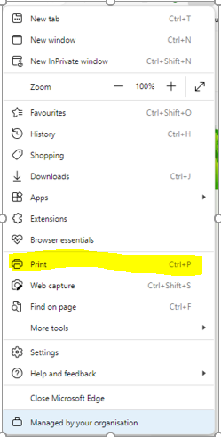
A quick way to access this is to use Ctrl P.
If you are using an older Microsoft Browser, it should still have the File Print Option, or use the Ctrl P shortcut to get the print option.

